English 2 GREETINGS, Prepositions of time, Living in a village vs town vs city
March 7, 2023
- Greetings in English
- Formal vs informal

  - 1. Good morning, Good afternoon or Good evening
  - 2. It’s nice to meet you or Pleased to meet you

  - 3. How have you been?
  - 4. How do you do?

This greeting is VERY formal, and quite uncommon and old-fashioned now, but it may still be used by some older people.
The proper response is “I’m doing well” or, as strange as it seems, some people even ask “how do you do?” right back as an answer.

- Informal Greetings in English

  - 5. Hey, Hey man or Hi

  - 7. How’s it going? or How are you doing?
  - 8. What’s up? What’s new? or What’s going on?
  - 9. How’s everything? How are things? or How’s life?
  - 10. How’s your day? or How’s your day going?
  - 11. Good to see you or Nice to see you

  - 12. Long time no see! or It’s been a while

Slang expressions:

  - 13. Yo!
  - 14. Are you OK?, You alright? or Alright mate?
  - 15. Howdy!
  - 16. Sup? or Whazzup?
  - 17. G’day mate!
  - 18. Hiya!

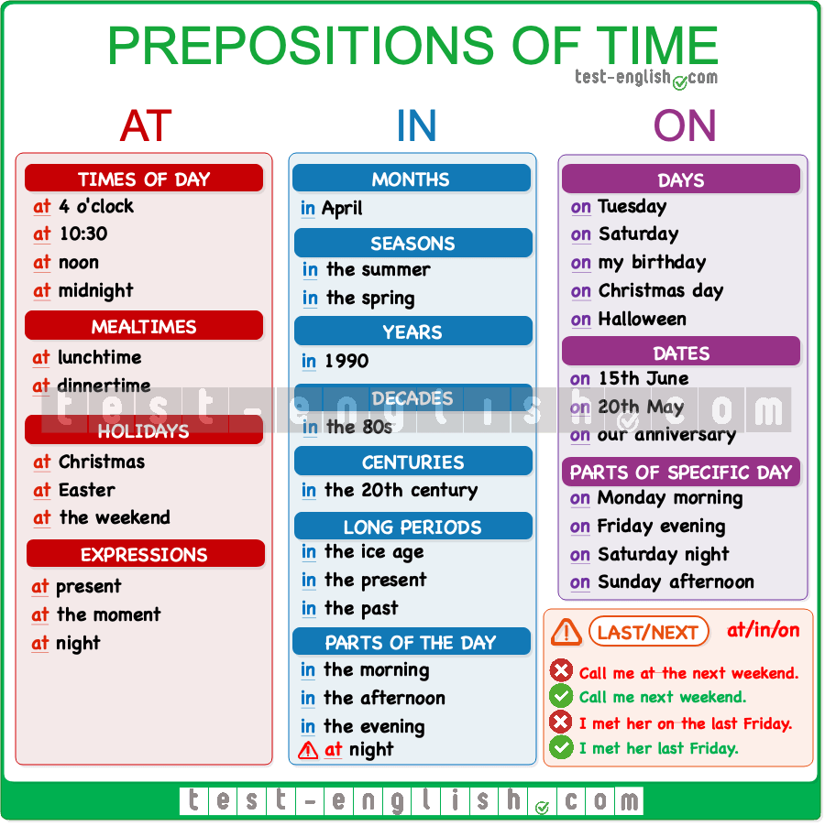

IN three days
DURING holidays
UNTIL 10 pm

City versus countryside – speaking
Write a list of advantages and disadvantages

