
PAST CONTINUOUS
- The Past Continuous is used when talking about something that was in progress at a particular time in the past.
e.g. They were dancing when I arrived at the hotel.

- We form the past Continuous from the past tense of be (was/were) + ing form.
A) Imagine you arrived at the Hotel yesterday at 3 o’clock. What were these people doing? – Write sentences. There are some verbs in the box that will help you:
- ___________________
- ___________________
- ___________________
- ___________________
- ___________________
- ___________________
- ___________________
- ___________________
- ___________________
- ___________________
- ___________________
- ___________________

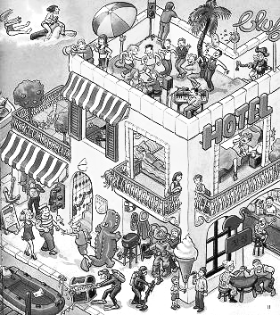
Walk drink dance fall

Lay sleep watch eat

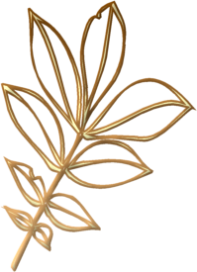

B) Fill in the gaps with the past continuous of the verbs in brackets.

- Mark __________ (study) when the telephone rang.
- They __________ ( not/watch) TV when Susan arrived.
- _________ we __________ (shop) when we met Susan?
- I remember _________ (not play) tennis at that time.
- When I ___________ (make) lunch, Susan called me.
- _______ James _______ (do) his homework when his mother asked him for help?
- While I _________ (cross) the street, a car had a puncture.
- The teacher ________ (not/talk) when John arrived.
- The pupils _________ (play) when the bell rang.
- Lucy _________ (study) when someone knocked at the door.
- ________ one of the students ________ (cheat) when the teacher looked at her?

C) Make sentences with past continuous verbs.

- When I walked in /children fight (affirmative)

- At 9.00 on Sunday we watch TV. (Affirmative.)

- When I saw him he was holding a paper /but he read (negative)

- When you heard them, they speak English? (question)

