Public places / directions / Prepositions

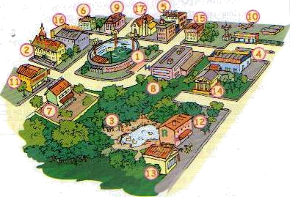
1 – Stadium
2 – Town Hall
3 – Park
4 - Supermarket
5 – Police station
6 – Library
7- School
8 – Hospital
9 – Post office
10 – Airport
11 – Theatre
12 - Restaurant
13 – Underground station
14 – Museum
15 – Bank
16 – Cinema
17 – Church

Useful information

Directions

Go down this street.
Go straight ahead
Turn left (right)
Take the first (second…etc) turning

Prepositions

Down, up, across, along, into, through, next to, at the corner opposite
Near, far from ...

During his holidays James visited some friends at school. Then he had to meet his group in the library to look for a nice restaurant for lunch.
He asked a police officer the way from school to the library but he doesn't know the way to the restaurant either. Can you help him?

- First complete the dialogue with the directions that the police officer gave to James.

James: Excuse me. Can you tell me the way to the library?

Police officer: It is not far from here. You can go on foot. It is ______ the Town Hall. Go ______ the street, take the first _______ on the left and then turn ________. The building at the corner is __________. Next to it there’s the ________and the library is _________ the cinema.
James: Thank you very much.

Police officer: You're welcome.

- How can James get from Library to the restaurant? Find the way and then write the directions.

When you leave the library, _____________________________________________________________________________________________________________________________________________________________________________________________________________________________________________________________________________________________________________________________________________________________________________________________________________________________________________________________________________________________________________________________________________________________________

