AT THE AIRPORT

-useful phrases

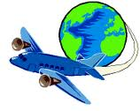
Can I have your ticket, please?
How much luggage do you have?
How many suitcases have you got?
This is my hand luggage.
Can I have a seat next to the window?
Here’s your boarding pass.
Where is passport control?
Follow the signs.
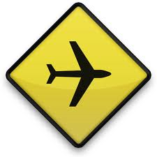
Can I see your passport, please?
Where can I get a trolley for my luggage?
Where is the information desk?
Which gate for flight number...?
The gate number is on the departure board.
How much is it for excess baggage?
How much hand luggage can I have?
Now go through passport control.
Wait for the flight in the departure lounge.
Check the departure gate.
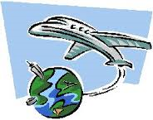
It’s now boarding.
The flight is delayed.
This is the last call.
Please board the plane.
Where is the arrival hall?
I have nothing to declare.
Do I have to pay customs duty on this?
How much is it?
How many can I bring in duty-free?
- Match the halves.

1. hand ……. a. free
2. boarding ….. b. luggage
3. passport ….. c. to declare
4. luggage …… d. lounge
5. information….. e. duty
6. flight …… f. gate
7. departure…… g. board
8. excess h. pass
9. departure i. trolley
10. departure j. call
11. last k. number
12. nothing l. control
13. custom m. desk
14. duty n. luggage

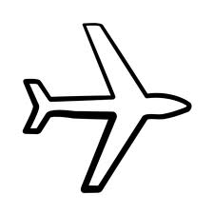

II. Read the dialogue and fill in the missing words.

- Can I have your ticket, please?
- Certainly, here you are.
- How much ……………… do you have?
- Two suitcases. This small bag is my ……………luggage.
- That’s fine.
- Can I have a …………….next to the window?
- I’ll check. Yes, that’s OK. Here’s your ……………pass. Have a nice ……………………..
- Thank you. And where is passport……………………..?
- Over there. Follow the signs.
- Can I see your……………., please?
- Of, course. Here you are.
- Thank you very much. That’s fine.

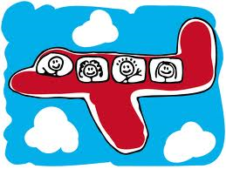

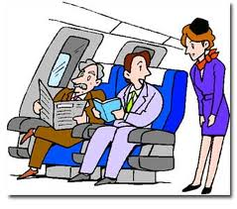
III. Match the halves to make sentences.

1. Where is the …… a. two weeks.
2. Which gate for …… b. next to the window?
3. How much …… c. information desk?
4. Can I have a seat …… d. holiday to the seaside.
5. I’m going on …… e. flight number BA 7413 to Rome?
6. I’m staying for …… f. luggage can I have?

IV. Rearrange the dialogue.

Passport Control

……… I'm a tourist.
……… Good morning. Can I see your passport?
……… That's fine. Have a pleasant stay.
……… Thank you.
……… Here you are.
……… Thank you very much. Are you a tourist or on business?

