Sleep, Dreams and Nightmares
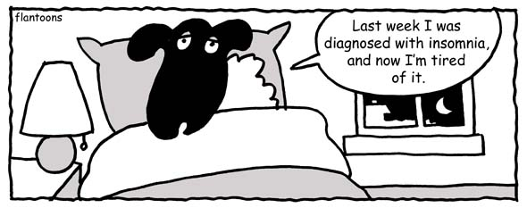
A. Match the idioms to their definitions:

1.recharge batteries (a) sleep soundly
2.shuteye (b) very early in the morning
3.not sleep a wink (c) sleep (informal)
4.catnap (d) short sleep
5.hit the hay (e) go to bed
6.sleep like a log (f) not sleep at all
7.toss and turn (g) be constantly moving in bed
8.beauty sleep unable to sleep
9. wide awake (h) regain energy be sleeping or
10. crack of dawn resting
(i) fully awake
(j) sleep before midnight or as
recommended by health
professionals (about 8 hours
for adults) to preserve
youthful looks

B. Ask your partner and answer the following questions
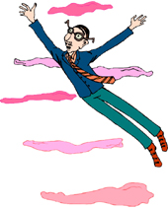 | What time do you usually go to bed?  What time do you usually get up?  Do you ever stay up all night? Why?  Do you usually sleep in on the weekend?  Are you a light sleeper or a heavy sleeper?  Do you snore?  Do you ever drool in your sleep?  Do you use an alarm clock? What time is it set for?  Who usually wakes you up in the morning?  Do you ever have insomnia?  What is a good cure for insomnia? What do you usually do when you have insomnia?
What do you usually do just before you go to bed?
Do you ever take naps during the day?
What do you do when you are tired but you have work to do?
Do you drink coffee in the morning?
Are you an early bird or a night owl?
When you were young did you sleep with a stuffed animal?

Describe your dreams:

Have you ever dreamt that . . .  . . . you were falling?  . . . you were taking a test?  . . . you were speaking in another language?  . . . you found some money?  . . . you received a present?  . . . were being chased but you couldn’t run? |  | 