1 SHE - READ



2 THEY - EAT



3 WE – DRINK



4 HE – WORK OUT



5 YOU – RUN



6 I – COOK

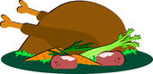

7 HE - PAINT



8 WE - LISTEN



9 SHE - FIGHT



10 YOU - TRAVEL



11 I – TAKE



12 THEY - SUNBATH

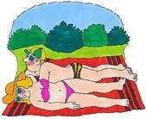

13 WE - STUDY



14 THEY – GO



15 I – PLAY



16 YOU - SLEEP

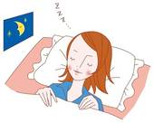

17 HE – WASH



18 WE – BUILD



19 YOU – WRITE



20 SHE – CLIMB



21 THEY- BAKE



22 HE – DRAW

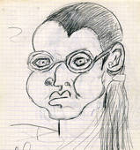

23 I – HAVE



24 YOU - MEET



25 WE – DO



26 I – WATCH



27 SHE – RIDE



28 IT – BARK



29 SHE – BUY



30 THEY – VISIT



HOME

**ANSWERS**

1

She is reading a book.

2

They are eating a pizza.

3

We are drinking lemonade.

4

He is working out.

5

You are running.

6

I’m cooking dinner.

7

He is painting the house.

8

We are listening to music.

9

She is fighting karate.

10

You are travelling around the world.

11

I’m taking a taxi.

12

They are sunbathing.

13

We are studying in the library.

14

They are going to the zoo.

15

I’m playing tennis.

16

You are sleeping .

17

He’s washing the car.

18

We are building a sandcastle.

19

You are writing a letter.

20

She is climbing a tree.

21

They are baking a cake.

22

He is drawing a portrait.

23

I’m having a shower.

24

You are meeting friends.

25

We are doing homework.

26

I am watching TV.

27

She’s riding a bike.

28

It’s barking.

29

She’s buying shoes.

30

They are visiting the pyramids.

HOME

**Instructions for the teacher**

**Preparation**

* Print the board games on tick paper or a cardboard; laminate them if you want to use them many times.
* Find tokens for each student.
* Provide dice.
* Divide the class into groups of 3 – 4 students each.
* Give each group a board game and a die.
* Give each student a token (or bean, coin, button, etc.).

**The game**

* The players put their tokens on the first square.
* The first student throws the die and moves his token ahead the corresponding number of squares.
* The student says what the person is doing in the given situation according to the pronoun and the picture..
* **Example: She is reading a book.**
* If the answer is correct, the student stays, if the answer is incorrect, he has to go back where he came from
* The first student who takes a number that places his token on “home” or surpasses it is the winner.